NATIONAL ARTIFICIAL INTELLIGENCE

DAY

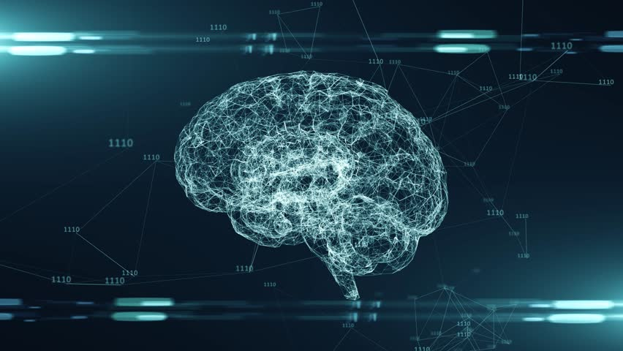

Artificial intelligence (AI) is a topic that has been discussed in philosophy and science fiction for decades but has rapidly become a reality.

In 2017, AI became a household name. It was all over the news every day with companies like Google investing billions of dollars into developing more and more AI applications.

AI covers some fascinating areas, from how we design intelligent machines to what our future might look like when these machines are more ubiquitous than humans.

An example might be when Siri tells you when it will rain in your city today.

In this article, let’s break down the basics of AI so you can better understand what it means more simplistically.

### Topics Covered In This Article

* What is artificial intelligence?
* What is machine learning?
* What is deep learning?

### What Do People Think Of AI?

When people are asked about AI, they usually think of Hollywood blockbusters like The Terminator.

It’s not surprising that someone who has never heard nor seen any mention about artificial intelligence before often conjures up images similar to movies such as The Terminator— something which most might consider an accurate representation.

They think we are at a point where AI applications can do all things for us— take care of our jobs, make decisions without consulting with humans, and so forth.

### What Is Artificial Intelligence?

Artificial intelligence involves using computers to do things that traditionally require human intelligence.

But what exactly is it? And why are we so excited about it?

Artificial intelligence is the science of making machines that can think like humans. It can do things that are considered "smart."

AI technology can process large amounts of data in ways, unlike humans. The goal for AI is to be able to do things such as recognize patterns, make decisions, and judge like humans. To do this, we need lots of data incorporated into them.

AI technology is at the very foundation of some things, such as image recognition and classification. It's also changing how we make decisions— for example, it can be used to predict traffic light systems or when you get your coffee in the morning.

### What Is Machine Learning?

Machine learning (ML) is a subset of artificial intelligence and is a science of getting computers to learn and act as humans do.

In traditional programming, a computer is given input data and an algorithm to produce an output.

If a computer is given input data with the corresponding output data, it can learn the algorithm itself and, therefore, continue to predict the right output data. This is called supervised learning.

Alternatively, if a computer is given a complex set of input data with no corresponding output data, the machine identifies the relationships in the data to provide valuable insights for decision-makers. This is called unsupervised learning.

### Why Is Machine Learning Such A Big Deal?

Since the advent of machine learning, programming has become easier.

Before machine learning became